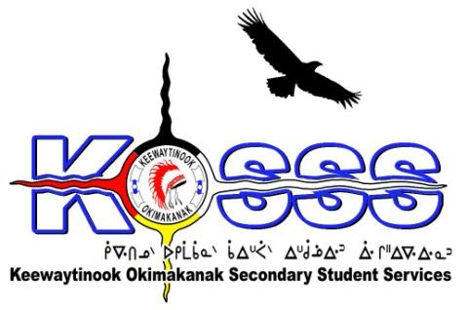
KEEWAYTINOOK OKIMAKANAK SECONDARY
STUDENT SERVICES (KOSSS)
1046 Memorial Avenue
Thunder Bay, Ontario P7B 4A3
Phone: (807) 346-4204 Ext. 1709
Fax: (807) 346-4330
Toll Free: 1-888-893-4111

Keewaytinook Okimakanak Secondary Student Services
Report Management & Intake Coordinator Required- One year Contract with Benefits and the Possibility of Extension

Keewaytinook Okimakanak Secondary Student Services (KOSSS) is seeking one (1) full-time Report Management & Intake Coordinator. The position will be based in Thunder Bay and will begin January 2018 and extend to March 2019.
The KOSSS Report Management & Intake Coordinator will develop processes for the effective management of the Community Electronic Medical Record (cEMR) database. The coordinator will support the KOSSS Health & Well-Being Coordinator, along with the KOSSS mental health team, to ensure program reporting requirements are met. The Report Management & Intake Coordinator will also work with the KOSSS Office Manager to track all student intakes that are completed (twice/year) and input all student information, consents and updates to the student files and electronic records. The coordinator will work with the KO cEMR Project Manager to manage the cEMR database to suit the needs of the KOSSS program.

The following are the requirements for this position:
Qualifications
- education related work experience
- College Diploma or Equivalent Experience and training or education-related position
- Knowledge of First Nation education issues, challenges, and delivery models
- Knowledge of the Jordan’s Principle Initiative and or willing to learn
- Ability to speak one of the local dialects is an asset
- Strong Interpersonal Skills
- Valid Class G Driver’s License
- Must be willing to provide a police criminal background check
- Able to work effectively with others
- Ability to work independently
- Strong communication skills with proficiency in developing written communications and the development of presentations

Duties will include, but may not be limited to:

The Report Management & Intake Coordinator will take direction from the KOSSS Health & Well-Being Coordinator, the KOSSS Education Coordinator, under the overall authority of the KOBE.

- Development of materials related to Jordan’s Principle and the KOSSS Mental Health Team;
- Work with the KO cEMR Project Manager to ensure the cEMR database reflects the needs of the KOSSS program;
- Sharing of information with the KOSSS Education Staff, KOBE Board of Directors and KO First Nations;
- Input of all student records and case management information;
- Track and record service gaps and successes;
- Meet reporting requirements of funding agencies;
- Travel to the Keewaytinook Okimakanak communities: Deer Lake, Fort Severn, Keewaywin, McDowell Lake, North Spirit Lake and Poplar Hill First Nations;
- Other related duties as set by the KO Board of Education

Salary will be based on a combination of qualifications and experience.

Deadline: Tuesday January 8, 2018 by 1:00 P.M. EST

FAX: 1.807.346.4330
Email: Resumes to: henryowusu@edu.knet.ca

