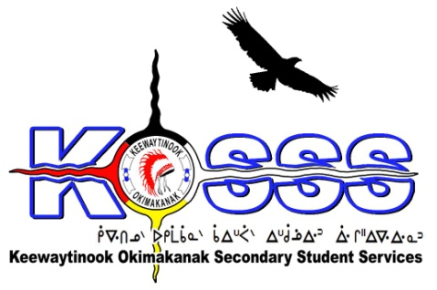
KEEWAYTINOOK OKIMAKANAK SECONDARY
STUDENT SERVICES (KOSSS)
1046 Memorial Avenue
Thunder Bay, Ontario P7B 4A3
Phone: (807) 346-4204 Ext. 1709
Fax: (807) 346-4330
Toll Free: 1-888-893-4111

Keewaytinook Okimakanak Secondary Student Services
Inquest Coordinator Required-Contract Term
Keewaytinook Okimakanak Secondary Student Services is looking to fill one full-time position, Inquest Coordinator from January to March 31, 2017. This position will be located in Thunder Bay, Ontario. Following the recommendations delivered by the Jury for the Thunder Bay Seven Youth Inquest (Inquest), a number of the parties identified are working together to move forward on the implementation of the recommendations. In order to ensure that Northern Nishnawbe Education Council (NNEC), Matawa First Nations Management (MFNM), Keewaytinook Okimakanak (KO) and Nishnawbe Aski Nation (NAN) can move forward both independently and collectively, the need has been identified for Inquest Coordinator positions to work with the organizations identified above.
The following are the requirements for this position:

Qualifications
- 5+ years education related work experience
- Bachelor’s Degree or Equivalent Experience and training or education-related position
- Knowledge of First Nation education issues, challenges, and delivery models
- Knowledge of the Jury Recommendations on the Thunder Bay Seven Youth Inquest
- Ability to speak one of the local dialects is an asset
- Strong Interpersonal Skills
- Valid Class G Driver’s License
- Must be willing to provide a police criminal background check
- Able to work effectively with others
- Ability to work independently
- Strong communication skills with proficiency in developing written communications and the development and delivery of oral presentations
- Willing to travel to the communities

Duties will include, but may not be limited to:
Inquest Coordinator will take direction from each partner organization based on prioritization of needs.

- Support and or lead implementation of the Inquest Recommendations (IR)
- Coordination of meetings, travel, proposals, reporting, training and materials related to IR
- Attend meetings with partners, including but not limited to (as determined by each individual organization):
-The City of Thunder bay
-Thunder Bay Police Service
-Canada
-Indian and Northern Affairs Canada
-Health Canada
-Ontario
-Ministry of Education
-Northern Nishnawbe Education Council
-Matawa First Nations Management
-Keewaytinook Okimakanak
-Nishnawbe Aski Nation
- Liaison and share of information with First Nations, community organizations, government agencies, and other parties to the inquest
- Track and record status of Inquest Recommendations and progress being made related to the recommendations
- Identify budget commitments from Provincial and Federal Governments and opportunities to secure funding for implementation of the recommendations
- Travel where needed
- Other duties related to the Inquest as set by the KO Board of Education

Hourly Wage will be based on a combination of qualifications and experience.

Deadline for the above Position is: January 16, 2017 by 1:00 P.M. CST

Please FAX or E-Mail Resumes to: 1-807-346-4330 or email to henryowusu@knet.ca

